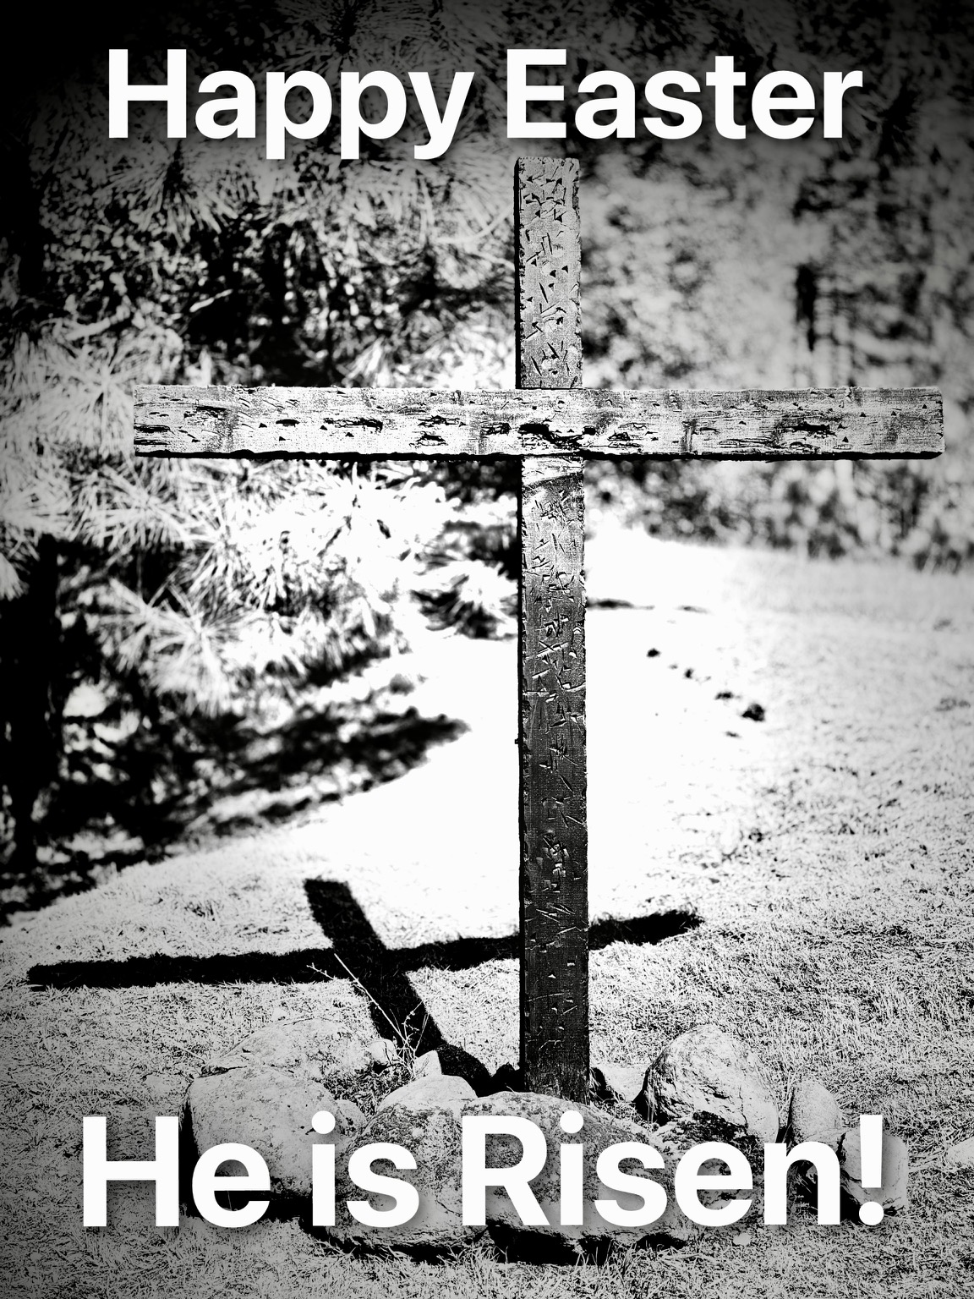**AT THE CROSS**

There’s a place where mercy reigns and never dies

There’s a place where streams of grace

flow deep and wide

All the love, I’ve ever found

Comes like a flood, come flowing down

**CHORUS**  
[At the cross, At the cross  
I surrender my life  
I'm in awe of You, I'm in awe of You  
Where Your love ran red, and my sin washed white  
I owe all to You, I owe all to You Jesus](https://genius.com/10578740/Chris-tomlin-at-the-cross-love-ran-red/At-the-cross-at-the-cross-i-surrender-my-life-im-in-awe-of-you-im-in-awe-of-you-where-your-love-ran-red-and-my-sin-washed-white-i-owe-all-to-you-i-owe-all-to-you-jesus)

[There's a place where sin and shame are powerless](https://genius.com/10578757/Chris-tomlin-at-the-cross-love-ran-red/Theres-a-place-where-sin-and-shame-are-powerless)  
[Where my heart has peace with God and forgiveness](https://genius.com/10578758/Chris-tomlin-at-the-cross-love-ran-red/Where-my-heart-has-peace-with-god-and-forgiveness)  
Where all the love I've ever found  
Comes like a flood  
Comes flowing down

CHORUS

BRIDGE  
Here my hope is found, Here on holy ground  
Here I bow down, Here I bow  
Here arms open wide, Here You save my life  
Here I bow down  
Here I bow

CHORUS

**WHEN I REMEMBER**

When I remember Jesus died for me

I’ll never go back anymore

Hallelujah!

When I remember Jesus died for me

I’ll never go back anymore.

I said, No, no, no, no, no,

I’ll never go back anymore

Hallelujah!

No, no, no, no, no,

I’ll never go back anymore!

**TODAY IS A NEW DAY**

Oh, what joy I find

When mercy paints the skies

with every new sunrise

Everything will be alright

You’re always by my side

I’ll leave my cares behind

CHORUS

Shine, shine down, chase the clouds away

You cover us with grace

Today is a new day.

Oh, shine, shine down, Jesus on display

Sends the night away, today is a new day!

Open up our eyes

Lord we lift You high as earth and sky collide

We will live our faith, until we see Your face

We’ll forever be, walking in Your light eternally

CHORUS

BRIDGE: repeat x 3

So lift your eyes up to the skies above

And everything will be alright….CHORUS

**REJOICE IN THE LORD ALWAYS**

Rejoice in the Lord always

And again, I say, Rejoice

(repeat)

Rejoice, rejoice, and again

I say, rejoice (repeat)

**REVELATION SONG**

Worthy is the Lamb who was slain  
Holy, holy is He  
Sing a new song to Him who sits on  
Heaven's mercy seat

(repeat)

CHORUS

Holy, holy, holy is the Lord God Almighty  
Who was and is and is to come  
With all creation I sing praise to the King of kings  
You are my everything and I will adore You

Clothed in rainbows of living color  
Flashes of lightning, rolls of thunder

Blessing and honor strength and glory and power be  
To You: the only wise King

CHORUS

Filled with wonder, awestruck wonder  
At the mention of Your name  
Jesus, Your name is power, breath and living water  
Such a marvelous mystery

CHORUS

**YOU ARE MY KING**

I’m forgiven because You were forsaken

I’m accepted, You were condemned

I’m alive and well, Your Spirit is within me

Because You died and rose again!

CHORUS

Amazing love, how can it be

That You my King would die for me

Amazing love, I know it’s true

It’s my joy to honor You

In all I do, I honor You

BRIDGE:

You are my King

You are my King

Jesus, You are my King

Jesus, You are my King

Chorus